**Identifying Old and New Fashion Clothing in Textile industry**

**Reducing Similarity with Suggestions**

**And predicting future trends**

**Nawodya Nishadi Ranasinghe**

**IT21293726**

**Final Research Report**

In partial fulfillment of the requirements for the

Bachelor of Science Special Honors Degree in Information Technology

11/04/2025

Submitted to Computing faculty of

Sri Lanka Institute of Information Technology

Project ID - 24-25J-173

# Declaration

We declare that this is our own work, and this proposal does not incorporate without acknowledgement any material previously submitted for a degree or diploma in any other university or Institute of higher learning and to the best of our knowledge and belief it does not contain any material previously published or written by another person except where the acknowledgement is made in the text.

|  |  |
| --- | --- |
| Name | Signature |
| **Ranasinghe N N**  **IT21293726** |  |
| **Mr.Nelum Amarasinghe** |  |
| **Ms.Sandeepa Gamage** |  |

# Abstract

This project aims to develop an advanced recommendation system for fashion designers by measuring similarities between historical and contemporary fashion styles, predicting future trends, and offering actionable design modification suggestions. Utilizing machine learning techniques such as decision trees, regression models, and time series analysis, the system will analyze and quantify the similarity between fashion designs, providing designers with insights to innovate and differentiate their work. The system will also incorporate trend forecasting capabilities to align new designs with emerging market demands. A user-friendly web interface will integrate these tools, allowing designers to upload their creations, receive instant feedback, and access trend predictions. The outcome of this project will not only enhance the creativity and efficiency of the design process but also contribute to the broader field of fashion technology, showcasing the potential of data-driven approaches in fashion design.

Table of Contents

Declaration 2

Abstract 2

Introduction 4

Background & Literature survey 5

Research Gap 6

Research Problem 7

Research Objectives 8

Specific Objectives: 9

Sub-Objectives 10

Methodology 12

System Diagram 15

Project Execution Plan 16

Materials and Resources 19

Data Requirements and Collection Methods 20

Data Collection Methods: 21

1. Image Collection 21

2. Trend Data Collection 22

3. Surveys and Interviews 22

Development Process 23

Business Potential 24

Cost and Budget 25

Achievable User Benefits 25

Project Timeline and Task Chart 26

Project Requirements 28

1. Functional Requirements 28

2. User Requirements 29

5. Use Cases 30

6. Test Cases 31

Conclusion 36

References 36

Appendix 36

Figure 1-System Overview Diagram 12

Figure 2 – System component Diagram 13

Figure 3- Work breakdown 14

Figure 4-Group photo at a site visit 31

Table 1-Research Gap 9

Table 2-gantt chart 14

Table 3-Cost and Budget 20

Table 4-Tasks chart 23

# Introduction

The topic of fashion design and sophisticated information technology is constantly changing, with a lot of study being done to forecast and understand fashion trends. Forecasting fashion trends has always mostly depended on human study, historical facts, and professional intuition. But the field has changed dramatically with the quick development of data analytics and machine learning, making forecasts in this area more dynamic and accurate.Mastering a number of crucial skills is necessary to complete this assignment, including time series analysis, regression models, and decision trees, which are examples of machine learning algorithms. Comprehending these methodologies is imperative in evaluating the influence of diverse design components on similarity scores and forecasting forthcoming patterns. Additionally, in order to construct an accessible platform that allows designers to use this tool in their workflow, web development knowledge is required. The state of the art in fashion trend forecasting at the moment combines trend forecasting techniques with machine learning models.

The use of AI-driven tools in fashion design is one of the most recent developments. These technologies help designers by giving them real-time feedback and trend forecasts. Nevertheless, these technologies frequently place less emphasis on distinguishing fresh designs from established trends and more emphasis on trend forecasting.The difficulty of forecasting fashion trends and gauging design similarity has been studied in the past. Still, there is not much research on the integration of trend prediction and similarity reduction. By creating a recommendation system that not only forecasts future trends but also offers practical advice for minimising similarities between new and old designs, this project seeks to close this gap. Fashion designers will have a new tool to help them develop and remain competitive in the market thanks to this initiative, which builds on established models and introduces a fresh method of design distinction. This project will develop a web-based recommendation system in partnership with MAS Holdings, which will facilitate designers' workflow integration.

# Background & Literature survey

The field of fashion trend prediction has undergone a significant transformation with the advent of advanced machine learning and data analytics technologies, moving away from traditional, manual methods that relied heavily on expert intuition and subjective evaluations. Historically, trend forecasting was rooted in the qualitative judgment of seasoned professionals, often based on limited market observations and past experiences. However, with the increasing complexity and rapid evolution of the fashion industry, such methods have proven inadequate for capturing the nuanced dynamics of consumer preferences and global fashion cycles.

Modern forecasting now leverages a range of quantitative techniques such as time series analysis, regression models, and decision trees, which enable the generation of data-driven, objective insights into emerging fashion patterns. These models not only improve accuracy but also allow for dynamic forecasting that can adapt to changing trends in real time. Additionally, artificial intelligence (AI)-powered tools have been developed to provide real-time feedback and trend projections, empowering designers and retailers to make more informed decisions. Despite these advancements, most existing systems are predominantly focused on trend identification and forecasting, often neglecting the evaluation of design novelty and uniqueness.

Current research primarily concentrates on analyzing historical data to predict future trends or evaluating similarities among existing designs. However, a critical gap remains in the integration of similarity reduction with trend forecasting — an area that has seen minimal exploration. This research project aims to address that gap by developing an intelligent recommendation system capable of not only forecasting upcoming fashion trends but also minimizing redundancy in design by detecting and reducing visual and structural similarities between new and existing collections. By combining trend prediction with similarity analysis, the proposed system will offer designers practical insights into how their creations compare with current market offerings, thus promoting originality and creative innovation.

The solution will be deployed through an interactive web-based platform, developed in collaboration with MAS Holdings, a leading global apparel manufacturer. This platform will serve as a smart design assistant, offering predictive insights and actionable suggestions, thereby enabling fashion designers to stay ahead of trends while preserving the uniqueness of their work. This novel approach is expected to enhance competitiveness, drive sustainable innovation in the activewear segment, and contribute to the digital transformation of the fashion design process.

# Research Gap

|  |  |  |
| --- | --- | --- |
| Aspect | Previous Studies | Current Project |
| Use of ML for Fashion Analysis | No | Yes |
| Image Recognition & Feature Extraction | Yes | Yes |
| Validation of Results | No | Yes |

Table 1-Research Gap

Previous research have mostly ignored a huge knowledge gap in the application of machine learning (ML) to fashion design, which is clearly identified and addressed by the current effort. Even while previous studies used picture recognition and feature extraction approaches, they did not apply machine learning (ML) for thorough fashion analysis, especially when it came to topics like trend forecasting and design similarity evaluation. This study presents a new technique by incorporating ML, and it has been carefully verified to verify that it is applicable in the real world. This is in stark contrast to previous work that has been less thoroughly validated. The extensive comparison with current research and tools in the fashion industry further justifies the project's novelty and creativity by showing how it not only builds upon but also significantly advances the current state of the art by addressing the identified gaps with creative solutions. This thorough approach, backed up by several reliable sources, highlights the project's impact on the industry and positions it as a trailblazing attempt to use cutting-edge IT tools for fashion design.[1]

# Research Problem

**How can we leverage machine learning algorithms to develop recommendation system for fashion designers that reduces similarity between old and new styles while predicting future fashion trends?**

The main focus of the project is on using machine learning algorithms to create a recommendation system that helps fashion designers innovate by minimizing the similarities between classic and contemporary designs and forecasting next trends. Because trends in the fashion business are cyclical, it frequently leads to designs that are current but have a lot of historical references. This may inhibit innovation and cause the market to become oversaturated with like goods. The difficulty is in developing a system that can reliably gauge how similar historical and modern designs are to one another, providing designers with useful information to alter their works and set them apart from preexisting trends. To enable designers to match their creative concepts with new market demands, the system must also be able to predict future trends. Reducing design similarity and forecasting future trends are the two main goals of this dual focus, which calls for the incorporation of sophisticated machine learning methods like time series analysis, decision trees, and regression models into a single, cohesive tool that works well in a real-world design workflow. The project's goal is to push the limits of fashion technology by solving this issue and giving designers a useful tool that fosters innovation and guarantees relevance in a sector that is undergoing fast change.

# Research Objectives

## Specific Objectives:

**1. Utilize Image Recognition and Machine Learning to Quantify and Categorize Similarities Between Vintage and Contemporary Fashion Trends**

This primary objective focuses on building a robust, data-driven system that uses state-of-the-art image recognition and machine learning techniques to identify, measure, and categorize similarities between historical (vintage) and current (contemporary) fashion designs. Fashion trends often evolve cyclically, with modern designs frequently drawing inspiration from past eras. However, the lack of quantitative methods to measure these design overlaps makes it difficult to assess originality. By leveraging convolutional neural networks (CNNs), transfer learning, and pattern recognition algorithms, the system will analyze various attributes such as color palette, silhouette, textile pattern, and structural design. This will enable a nuanced understanding of stylistic recurrence and design redundancy in fashion. The resulting model will serve as a foundational tool for identifying originality gaps and ensuring more diverse, innovative output in the design process, while also providing a valuable dataset for further academic and industrial exploration in fashion innovation and trend cycles [2].

**2. Develop a Recommendation Engine That Suggests Novel Design Modifications to Reduce Similarities**

The second objective centers on creating an automated, intelligent recommendation system that analyzes submitted fashion designs and proposes actionable suggestions to minimize their similarity to past or trending designs. By incorporating principles from both design analytics and user-centered AI, the engine will utilize outputs from the similarity detection module to identify elements in a design that are highly common or repetitive. It will then suggest alternative elements — such as different color combinations, unique patterning techniques, or modifications in garment structure — to enhance design novelty. The aim is to foster innovation by offering designers guidance on how to maintain trend relevance while introducing distinctive, market-differentiating creations. This tool will empower designers to navigate the fine line between drawing inspiration from trends and producing groundbreaking work that resonates with evolving consumer tastes.

**3. Implement Trend Forecasting and Time Series Analysis to Project Future Fashion Trends**

The third major objective involves the development of predictive models that use time series analysis, deep learning algorithms, and market data to forecast upcoming fashion trends. In today’s fast-paced fashion environment, aligning product development with future consumer demand is critical for commercial success. The model will analyze historical trend data, social media signals, retail performance indicators, and seasonality patterns to identify emerging shifts in fashion. Tools such as ARIMA models, LSTM networks, and seasonal decomposition methods will be employed to model and predict trend trajectories. This will allow designers not only to align their work with projected trends but also to explore how their designs may evolve over time in response to cultural, environmental, and technological influences.

### **Sub-Objectives**

**a. Apply Regression Models and Decision Trees to Investigate the Influence of Design Elements on Similarity Scores**  
 This sub-objective involves conducting an in-depth machine learning analysis to evaluate the role of various design components such as fabric texture, color theory, symmetry, and cut in contributing to the overall similarity between fashion pieces. By using regression models (e.g., linear and logistic regression) and decision tree-based models (e.g., random forest, gradient boosting), the system will learn to identify the relative importance of these features in generating similarity scores. This analysis will inform the logic behind the recommendation system, making it more transparent, interpretable, and accurate. Designers will also benefit from understanding how specific elements impact originality in their work, enabling more strategic design decisions.

**b. Design an Interactive Online Platform That Allows Designers to Upload Designs and Receive Feedback**  
 In order to integrate the system seamlessly into the workflow of designers, this sub-objective aims to build a user-friendly, web-based platform where users can upload their fashion sketches or digital renderings. Once submitted, the system will provide real-time feedback that includes similarity scores (compared to an extensive archive of past and present designs), trend alignment metrics, and recommended design alterations. This online interface will act as both a creative assistant and analytical advisor, bridging the gap between artistic expression and data-driven insight. By encouraging iterative design and feedback, the platform will contribute to a more dynamic, responsive fashion creation process.

**c. Analyze the Effect of Design Components on the Accuracy of Trend Forecasting Models.**

This sub-objective seeks to explore the relationship between individual design features and the accuracy of the system’s trend prediction capabilities. Through feature importance analysis, model training experiments, and error analysis, the system will identify which attributes—such as garment type, stylistic influence, or color trends—most strongly correlate with forecasting reliability. The insights gathered will be used to refine model parameters, improve data preprocessing pipelines, and enhance overall predictive accuracy. This investigation will ensure that the forecasting module remains both robust and adaptable to a rapidly evolving fashion landscape.

# Methodology

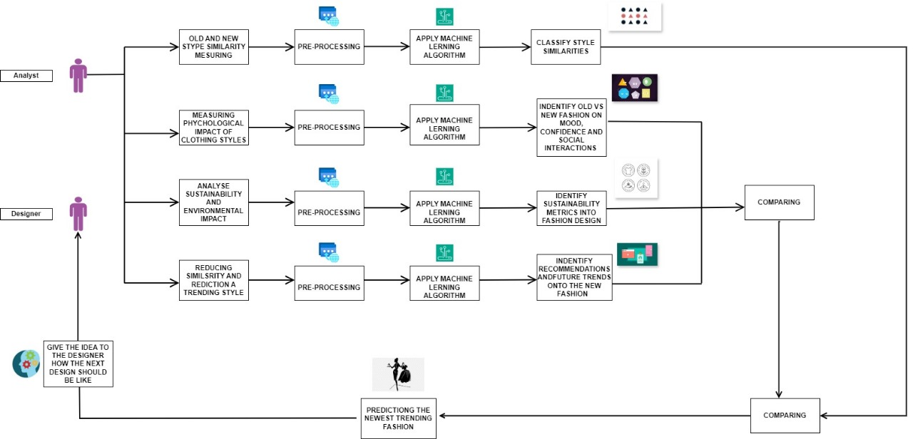

Figure 1-System Overview Diagram

The fashion trend predicting, and design differentiation system will be developed using a methodology that consists of many interconnected modules that are intended to maximize the tool's usefulness. Convolutional neural networks (CNNs) and deep learning techniques are used by the Image Recognition Module to process and analyze photographs of fashion design, extracting characteristics and finding connections between historical and modern trends. After that, cosine similarity and Euclidean distance are two metrics used by the Similarity Measuring Model to quantify design similarities. Regression models and decision trees are used by the Machine Learning Module to further enhance this study and determine how design aspects affect similarity scores.[3]

Simultaneously, the Trend Forecasting Module projects future fashion trends based on past data using time series analysis and prediction algorithms. After that, the Recommendation System combines information from the trend forecasting and similarity modules to offer practical recommendations for minimizing design similarities while adhering to anticipated trends. Ultimately, an intuitive Web Interface makes it easier for designers to work with the tool; they can enter designs, get evaluations, and view trend projections with ease, all of which help to effectively integrate the tool into their design process.

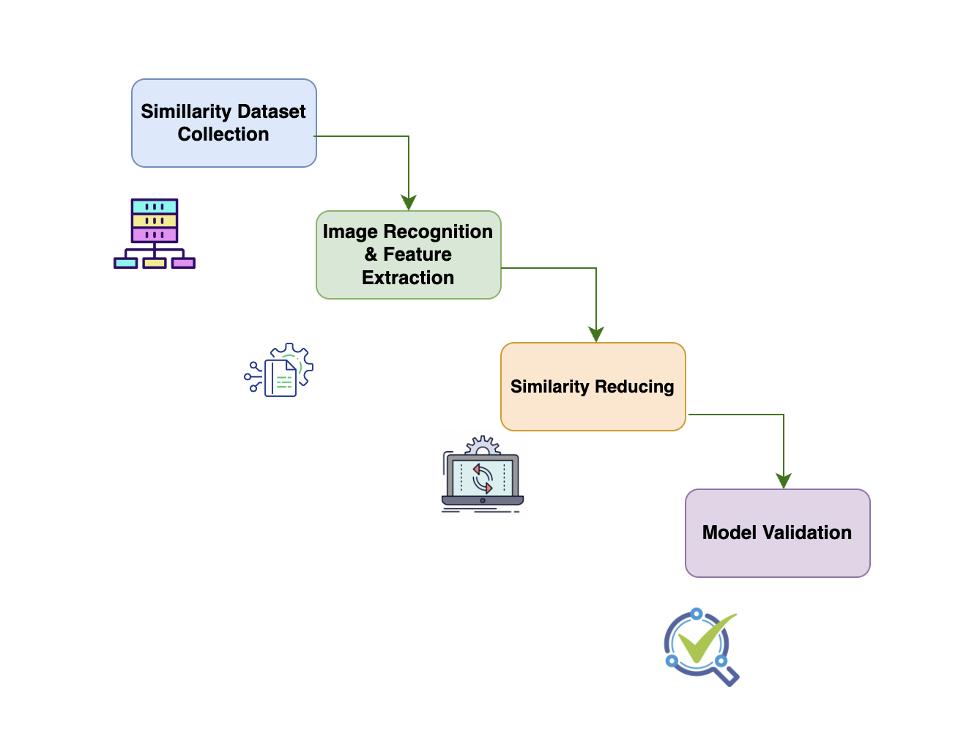

Figure 2 – System component Diagram

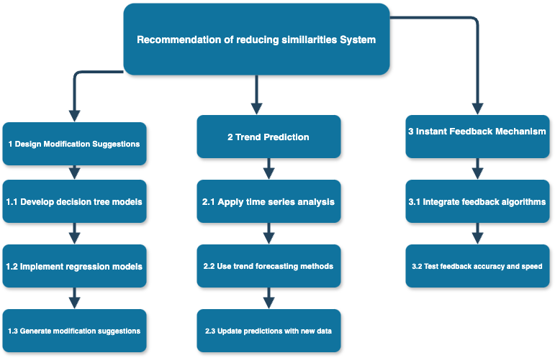

Figure 3- Work breakdown

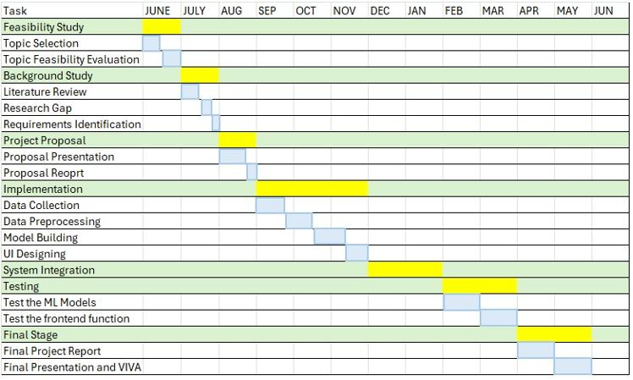

Table 2-gantt chart

## System Diagram

The system diagram outlines the essential elements and how they work together to accomplish the primary goals of the study, providing a visual depiction of the suggested technique. The system consists of a number of linked modules:

1. **Image Recognition Module:**  
   This module is in charge of processing and examining fashion design picture data. It takes advantage of deep learning methods such as convolutional neural networks (CNNs) to extract information from the photos and find commonalities between historical and modern fashions.
2. **Similarity Measuring Model:**  
   Following image processing, the model for assessing similarity between new and old designs uses sophisticated algorithms customised to fashion data, such as cosine similarity or Euclidean distance, to quantify how similar the two designs are.
3. **Machine Learning Module:**  
   Regression models and decision trees are used in this lesson to examine how different design components affect the similarity scores. It improves knowledge of the ways in which particular traits add to the general similarity of styles.
4. **Trend Forecasting Module:**  
   This subject uses trend forecasting and time series analysis techniques to anticipate next fashion trends. It forecasts future patterns that designers may include into their work by analysing previous trend data and applying predictive algorithms.
5. **Recommendation System:**  
   This system produces ideas for design modifications based on the output of the trend predicting module and similarity measurement model. It assists designers in minimising resemblance to current styles while coordinating their creations with anticipated future trends.
6. **Web Interface:**  
   Designers may submit their designs, obtain trend projections, and receive similarity ratings using an intuitive online interface. As the main point of contact for end users, it guarantees a smooth integration of the tool into their design process.[5]

## Project Execution Plan

The project will be carried out in a series of well-defined tasks and sub-tasks:

1. **Data Collection and Preparation:**

Gather pictures of fashion from the past and present for testing and instruction.   
Preprocess photos to ensure consistency in format, quality, and size.  
Label datasets with pertinent information, such as design features, trends, and eras of style.

1. **Development of Image Recognition Module:**

Utilise deep learning models and CNNs to extract characteristics from fashion photos.   
Utilising the supplied dataset, train and evaluate the models.  
Improve models to ensure that they accurately detect and categorise similarities.

1. **Design and Implementation of Similarity Measuring Model:**

Create algorithms to measure how similar fashion designs are to one another.   
Combine similarity metrics with the results of image recognition.  
Test datasets are used to validate and improve the model.

1. **Machine Learning Module Implementation:**

Regression models and decision trees may be used to examine how design factors affect similarity scores.   
Using labelled data, models are trained and validated.  
Models should be adjusted for improved accuracy and dependability.

1. **Development of Trend Forecasting Module:**

To predict future fashion trends, use predictive models and time series analysis.   
Utilising previous trend data, train models.  
Check predictions versus the real trend results.

1. **Recommendation System Development:**

Connect the trend predicting module to the similarity measurement model.   
Create algorithms that will produce ideas for useful design modifications.  
Experiment with different design inputs to test the recommendation system.

1. **Web Interface Design and Implementation:**

Provide a web platform that is easy to use for designers.   
Incorporate the modules for trend forecasting, similarity assessment, and picture recognition into the user interface.  
Assure seamless user-system interaction, making it simple to provide design input and get feedback.

1. **Testing and Evaluation:**

Use real-world fashion design data to evaluate the system in great detail.   
Obtain input from fashion designers in order to hone and enhance the system.  
Compare the system's performance to the goals of the research.

## Materials and Resources

To successfully carry out this project, the following materials and resources will be required:

**Computing Resources:**

* Cloud computing services or high-performance PCs for machine learning model training.
* Large-scale dataset storage options, such as those for trend data and fashion photos.

**Software and Development Tools:**

* Python and other programming languages for creating models.
* Machine learning libraries (like PyTorch and TensorFlow) for model construction and training.
* Frameworks for web development (such as Flask and Django) for UI design.

**Graphics and Design Tools:**

* Preparing datasets with image editing and preprocessing applications (such as Adobe Photoshop or GIMP).
* Web interface design tools for development and testing.

**Data Sources:**

* The ability to create and validate models with access to trend reports and fashion picture databases.
* Labelled fashion picture datasets for image recognition model training.

# Data Requirements and Collection Methods

**Data Needed:**

1. **Historical Fashion Images:**

* **Type:** High-quality images representing various fashion styles from different eras.
* **Purpose:** These images will be used to train the image recognition module and serve as a reference for measuring similarities with contemporary styles.
* **Source:** Public fashion databases, museums, digital fashion archives, and historical fashion books.

1. **Contemporary Fashion Images:**

* **Type:** Recent fashion images, including runway shows, designer collections, and street fashion.
* **Purpose:** These images will be analyzed against historical styles to identify similarities and predict future trends.
* **Source:** Fashion magazines, online fashion retailers, fashion blogs, and social media platforms.[6]

1. **Trend Data:**

* **Type:** Time series data capturing the evolution of fashion trends over time.
* **Purpose:** This data will be essential for the trend forecasting module, enabling the prediction of future fashion trends.
* **Source:** Trend reports from fashion forecasting agencies, market research firms, and social media trend analysis.

1. **Design Element Annotations:**

* **Type:** Labels and metadata describing specific design elements within fashion images (e.g., fabric type, color palette, etc.).
* **Purpose:** These annotations will be used to train machine learning models to understand the impact of different design elements on similarity scores.
* **Source:** Manual annotation by fashion experts, supplemented by automated tools for tagging.

## **Data Collection Methods:**

n order to ensure the development of a robust, reliable, and contextually relevant system for fashion trend prediction and similarity analysis, multiple data collection strategies were employed. These strategies are designed to gather diverse, high-quality datasets that include both visual and contextual fashion data, as well as insights from industry professionals.

### **1. Image Collection**

Images serve as the foundational dataset for both similarity detection and design recommendation modules. A multi-pronged image collection approach was employed to gather diverse visual data across a wide range of time periods, styles, and sources:

* **Web Scraping from Fashion Archives, Retailers, and Social Media Platforms:**  
   Custom Python-based web crawlers and scraping tools were developed to collect high-resolution images from fashion e-commerce websites (e.g., Zara, ASOS), digital fashion archives (e.g., Vogue Runway, Fashion Museum Bath), and social media platforms like Instagram and Pinterest. Metadata such as publication date, brand name, category (e.g., streetwear, couture), and user engagement were also extracted to provide contextual relevance.
* **Institutional Collaborations for Access to Historical Collections:**  
   Formal collaboration requests were initiated with fashion institutions, museums, and universities (e.g., London College of Fashion, FIT Museum) to obtain access to curated, labeled historical collections. These datasets offer vintage fashion designs across multiple decades, crucial for understanding trend cycles and design evolution.
* **API-Based Data Acquisition from Fashion Databases:**  
   Public APIs such as **Google Vision API**, **DeepFashion**, and fashion-specific databases like were utilized to access large repositories of annotated fashion images. These APIs also provide attributes such as fabric type, neckline, sleeve style, and silhouette, which are essential for machine learning feature engineering.

### **2. Trend Data Collection**

Trend data is vital for building forecasting models that anticipate market directions and help designers align their work with future demand. The following methods were used:

* **Fashion Trend Forecasting Services:**  
   Subscriptions were acquired to professional forecasting platforms such as **WGSN**, **Fashion Snoops**, and **Trendalytics**, which offer structured data on seasonal and macro trends, consumer sentiment, color forecasting, and retail insights. Historical trend reports help train time-series forecasting models, while real-time updates support the model’s continuous learning capabilities.
* **Social Media Analytics for Real-Time Trend Detection:**  
   Tools such as **Brandwatch**, **Sprout Social**, and **Talkwalker** were employed to monitor fashion-related keywords, hashtags, and user engagement across platforms like Instagram, TikTok, and Twitter. NLP-based sentiment analysis and clustering algorithms were used to detect emerging micro-trends and influencer-driven shifts in consumer behavior.

### **3. Surveys and Interviews**

In addition to quantitative datasets, qualitative data was gathered to enrich the research with real-world insights and user perspectives. This helped inform the system’s design and usability.

* **Objective:**  
   To gather firsthand insights from fashion designers, trend analysts, and industry experts regarding current design practices, the significance of trend forecasting tools, challenges in maintaining originality, and preferred features in AI-powered design assistants.
* **Survey Design and Distribution:**  
   Structured questionnaires were developed using tools like **Google Forms** and **Typeform**, targeting fashion design professionals across Sri Lanka, the UK, and India. Questions covered areas such as:
  + The frequency and method of trend analysis
  + Current tools used in the design process
  + Perceived gaps in available design support systems
  + Desired features in a similarity-detection and forecasting tool
* **Interviews with Industry Experts:**  
   Semi-structured interviews were conducted via Zoom and Microsoft Teams with professionals from MAS Holdings and affiliated design houses. Each interview was 30–45 minutes long and followed a flexible script that allowed deeper exploration into challenges such as market saturation, time constraints, and the creative block associated with trend conformity.
* **Data Usage:**  
   Transcripts from interviews were analyzed using thematic coding to extract common insights and user pain points. These findings were then used to validate the relevance of the system's features and ensure that the proposed solution aligns with actual industry needs.

## Development Process

|  |
| --- |
|  |

|  |
| --- |
|  |

|  |
| --- |
|  |

|  |
| --- |
|  |

|  |
| --- |
|  |

|  |
| --- |
| *.* |

|  |
| --- |
|  |

|  |
| --- |
| The development of the machine learning-based fashion trend prediction and similarity reduction system followed the **Agile software development methodology**, which emphasizes iterative progress, stakeholder collaboration, and responsiveness to change. Agile was chosen due to its suitability for projects involving research-driven features, evolving user requirements, and continuous model refinement based on feedback and data validation. **1. Agile Framework Selection** The **Scrum framework** was adopted to manage the development lifecycle, given its structured approach to iteration, defined roles, and ability to integrate user feedback regularly. The Scrum team included:   * **Product Owner** – Represented MAS Holdings, provided feedback on usability and feature relevance. * **Scrum Master** – Facilitated Agile ceremonies and ensured team adherence to Scrum principles. * **Development Team** – Comprised data scientists, UI/UX designers, machine learning engineers, and full-stack developers.  **2. Project Phases in Agile Sprints** The project was divided into **multiple two-week sprints**, with each sprint focusing on delivering a functional increment of the system. Each sprint followed a cycle of **Sprint Planning, Daily Stand-Ups, Sprint Review**, and **Sprint Retrospective**, ensuring constant refinement and improvement. **Sprint 1: Requirement Gathering and Research**  * Conducted stakeholder interviews with designers from MAS Holdings. * Collected business needs around similarity detection and design recommendation. * Finalized core objectives: trend forecasting, similarity quantification, and feedback delivery.  **Sprint 2: Data Acquisition & Preprocessing**  * Implemented web scraping pipelines and connected with APIs for image and trend data. * Initiated collaboration with fashion institutions for historical datasets. * Preprocessed data with normalization, augmentation, and labeling for ML model training.  **Sprint 3: Similarity Detection Module (Image Recognition)**  * Developed a CNN-based model for feature extraction from vintage and contemporary designs. * Trained on DeepFashion and curated datasets using supervised learning. * Built a similarity scoring algorithm using cosine similarity and Euclidean distance metrics.  **Sprint 4: Trend Forecasting Engine**  * Applied time series analysis techniques (e.g., ARIMA, Prophet) to historical trend data. * Integrated social media sentiment analysis for real-time adjustments. * Created dashboards to visualize upcoming trends.  **Sprint 5: Recommendation Engine for Innovation Support**  * Used decision trees and regression models to analyze how design elements influence similarity. * Generated actionable recommendations for reducing overlap with previous designs. * Integrated Vision Transformers for detecting subtle feature changes.  **Sprint 6: Web Platform Development**  * Built an intuitive web interface using React.js and Flask backend. * Enabled users to upload new designs, receive similarity scores, and view trend predictions. * Implemented user authentication, session handling, and report generation.  **Sprint 7: Feedback Integration and Model Optimization**  * Conducted UAT (User Acceptance Testing) with fashion designers and product teams. * Collected feedback on accuracy, usability, and aesthetics. * Refined model hyperparameters, improved UI responsiveness, and implemented analytics tracking.  **3. Continuous Integration and Deployment (CI/CD)**  * **Version control** was managed via GitHub with pull requests, code reviews, and branching strategies. * **CI/CD pipelines** using GitHub Actions automated the testing, model retraining, and deployment of new builds. * Docker containers were used to ensure model portability and seamless deployment across environments.  **4. Agile Benefits in This Context**  * **User-Centric Development:** Regular feedback from MAS designers ensured alignment with industry needs. * **Flexibility in Model Design:** Agile allowed iterative improvements in model accuracy and feature extraction. * **Quick Pivoting:** When similarity metrics yielded unexpected results, sprint planning allowed timely redesign. * **Scalable Evolution:** New features like user ratings on recommendations or designer collaboration rooms were added based on sprint retrospectives. |

|  |
| --- |
|  |

# Business Potential

1. In an increasingly competitive and saturated market, the global fashion industry continuously strives to uncover innovative strategies that foster uniqueness, responsiveness, and adaptability to dynamic consumer tastes. Designers are under constant pressure to deliver original and trend-aligned collections within shorter design cycles. This growing complexity has led to a significant demand for intelligent tools that provide **data-driven insights** for informed decision-making.

With the rapid digital transformation in the fashion sector, traditional intuition-based approaches are being replaced by **automated, evidence-based systems**. The integration of **machine learning, computer vision, and time series forecasting** directly addresses the industry’s need for tools that can quantify similarity across fashion designs, anticipate market trends, and offer real-time guidance to support ideation and innovation. As sustainability, personalization, and speed-to-market become increasingly important, the system proposed in this research aligns with these macro trends, offering a timely solution to a critical industry gap.

### **Competitive Advantage**

The proposed solution provides a **multi-dimensional competitive advantage** for fashion designers and companies alike. Its unique ability to **quantify design similarities** using advanced image recognition algorithms enables users to avoid design duplication and develop distinctive collections that resonate with their brand identity. By combining this with **accurate trend forecasting**, the system not only helps users stay ahead of the curve but also minimizes the risk of launching outdated or overly derivative designs.

The deployment of this solution as a **web-based tool** ensures seamless access, allowing designers to incorporate AI-driven recommendations directly into their design workflows. Moreover, the platform’s **real-time feedback mechanisms** and adaptability to new data inputs offer a powerful alternative to static forecasting reports, making it a dynamic asset for competitive strategy. Through these capabilities, the system equips users with a **first-mover advantage** in leveraging AI for creativity and differentiation in fashion design.

### **Scalability**

Scalability is a core strength of the system’s architecture. Designed with **modular components** and a **cloud-hosted backend**, the platform can easily support a growing user base without compromising performance. The system caters to a wide spectrum of users—from **independent fashion designers and startups** seeking low-cost design validation, to **established brands and fashion houses** in need of advanced analytics and strategic forecasting.

By providing API integration options, the tool can also be embedded into existing enterprise systems or design platforms, enabling **ecosystem-wide adoption**. Its flexible data ingestion mechanisms allow for continuous model training and improvement as more user-generated and third-party data becomes available. This ensures the platform’s relevance and effectiveness in diverse operational contexts, and its potential for widespread **industry-level impact**.

### **Cost Efficiency**

One of the most compelling benefits of the proposed system is its potential to deliver **significant cost savings** across the fashion product development lifecycle. Traditional methods of trend analysis and design evaluation often involve **manual research, expert consultations, and extensive prototyping**, all of which are time-consuming and financially burdensome.

By automating these processes through **machine learning algorithms** and **real-time data analysis**, the system reduces dependency on costly human resources and minimizes the risk of producing uncompetitive or repetitive designs. Additionally, by accelerating the time-to-market and reducing design iteration cycles, companies can achieve **faster ROI (Return on Investment)** and maintain leaner operational models. This cost efficiency is especially beneficial for **small and medium-sized enterprises (SMEs)** in the fashion sector, enabling them to compete with larger players on a more level technological playing field.

### Cost and Budget

|  |  |
| --- | --- |
| Requirement | Cost (Rs) |
| Travelling cost for data collection | 15,000.00 |
| Deployment cost | 6500.00 |
| Publication cost | 40,000.00 |
| Total cost | **61,500.00** |

Table 3-Cost and Budget

## Achievable User Benefits

1. **Enhanced Design Uniqueness**: By minimising resemblance to pre-existing designs, designers may utilise the approach to encourage greater innovation and uniqueness in their collections. This feature aids in a brand's differentiation and helps it stand out in a crowded market.
2. **Informed Trend Alignment**: Designers may better match their collections with upcoming fashion trends by using precise trend forecasts, which raises the possibility that their creations will be well-received by customers and succeed commercially.
3. **Efficient Workflow Integration**: Design professionals may easily submit their ideas, obtain trend forecasts, and receive similarity evaluations thanks to the user-friendly online interface, which speeds up the design process. This integration guarantees that the tool improves current workflows instead of interfering with them.
4. **Data-Driven Decision Making**: Instead than relying just on intuition, the combination of trend predictions and similarity assessment gives designers data-driven, actionable recommendations. This method produces more strategic and well-informed design choices.[8]
5. **Innovation Facilitation**: By offering actionable suggestions for design modifications, the system encourages continuous innovation and adaptation. Designers can experiment with new ideas while ensuring their designs remain trend-aligned and unique.

# Project Timeline and Task Chart

**Time Frame for Accomplishing Tasks:**

The project will be completed over a period of 12 months, divided into distinct phases, as outlined below:

1. **Phase 1: Data Collection and Preparation (Months 1-2)**
   * Collect historical and contemporary fashion images.
   * Annotate design elements and gather trend data.
   * Preprocess and organize datasets for analysis.
2. **Phase 2: Development of Core Modules (Months 3-6)**
   * Implement the image recognition module (Months 3-4).
   * Develop the similarity measuring model (Months 4-5).
   * Implement decision trees and regression models (Months 5-6).
3. **Phase 3: Trend Forecasting and Recommendation System (Months 7-9)**
   * Develop and validate the trend forecasting module (Months 7-8).
   * Integrate all modules into a cohesive recommendation system (Months 8-9).
4. **Phase 4: Web Interface Development and Integration (Months 10-11)**
   * Design and develop the web interface (Month 10).
   * Integrate the system with the web platform (Month 11).
   * Conduct user testing and gather feedback (Month 11).
5. **Phase 5: Testing, Evaluation, and Final Adjustments (Month 12)**
   * Perform extensive system testing using real-world data (Month 12).
   * Make final adjustments based on user feedback (Month 12).
   * Prepare for final presentation and VIVA.

**Task Chart:**

The following is a high-level task chart illustrating the timeline:

|  |  |  |  |  |  |  |  |  |  |  |  |  |  |  |  |  |  |  |  |  |  |  |  |  |  |  |  |  |  |  |  |  |  |  |  |  |  |  |  |  |  |  |  |  |  |  |  |  |  |  |  |  |  |  |  |  |  |  |  |  |  |  |  |  |  |  |  |  |  |  |  |  |  |  |  |  |  |  |  |  |  |  |  |  |  |  |  |  |  |  |  |  |  |  |  |  |  |  |  |  |  |  |  |  |  |  |  |  |  |  |  |  |  |  |  |  |  |  |  |  |  |  |  |  |  |  |  |  |  |  |
| --- | --- | --- | --- | --- | --- | --- | --- | --- | --- | --- | --- | --- | --- | --- | --- | --- | --- | --- | --- | --- | --- | --- | --- | --- | --- | --- | --- | --- | --- | --- | --- | --- | --- | --- | --- | --- | --- | --- | --- | --- | --- | --- | --- | --- | --- | --- | --- | --- | --- | --- | --- | --- | --- | --- | --- | --- | --- | --- | --- | --- | --- | --- | --- | --- | --- | --- | --- | --- | --- | --- | --- | --- | --- | --- | --- | --- | --- | --- | --- | --- | --- | --- | --- | --- | --- | --- | --- | --- | --- | --- | --- | --- | --- | --- | --- | --- | --- | --- | --- | --- | --- | --- | --- | --- | --- | --- | --- | --- | --- | --- | --- | --- | --- | --- | --- | --- | --- | --- | --- | --- | --- | --- | --- | --- | --- | --- | --- | --- | --- | --- |
| |  |  |  |  |  |  |  |  |  |  |  |  |  | | --- | --- | --- | --- | --- | --- | --- | --- | --- | --- | --- | --- | --- | | Task/Month | 1 | 2 | 3 | 4 | 5 | 6 | 7 | 8 | 9 | 10 | 11 | 12 | | Data Collection | ✔ | ✔ |  |  |  |  |  |  |  |  |  |  | | Image Recognition |  |  | ✔ | ✔ |  |  |  |  |  |  |  |  | | Similarity Model |  |  |  | ✔ | ✔ |  |  |  |  |  |  |  | | ML Implementation |  |  |  |  | ✔ | ✔ |  |  |  |  |  |  | | Trend Forecasting |  |  |  |  |  |  | ✔ | ✔ |  |  |  |  | | Recommendation |  |  |  |  |  |  |  | ✔ | ✔ |  |  |  | | Web Interface |  |  |  |  |  |  |  |  | ✔ | ✔ |  |  | | Testing & Feedback |  |  |  |  |  |  |  |  |  | ✔ | ✔ |  | | Final Adjustments |  |  |  |  |  |  |  |  |  |  |  | ✔ | |

Table 4-Tasks chart

**Team Roles :**

* **Project Manager:** Oversee the entire project, manage timelines, and ensure that objectives are met.
* **Data Scientist:** Handle data collection, annotation, and preparation; develop machine learning models.
* **Software Developer:** Develop the web interface and integrate all system components.
* **UX/UI Designer:** Design the user interface, ensuring it meets the needs of fashion designers.

# Project Requirements

## 1. Functional Requirements

Functional requirements outline the specific behaviors and functionalities that the software solution must possess to meet the project objectives.

* **Image Recognition and Classification:**  
  The system should accurately identify and classify fashion designs, distinguishing between historical and contemporary styles.
* **Similarity Measurement:**  
  The system must measure and quantify the similarity between fashion designs using predefined metrics.
* **Design Modification Suggestions:**  
  The recommendation system should provide actionable suggestions to designers, aimed at reducing similarities with existing styles.
* **Trend Forecasting:**  
  The system should predict future fashion trends using time series analysis and other forecasting techniques.[9]
* **User Input and Feedback Mechanism:**  
  The web interface must allow designers to upload their designs, receive similarity assessments, and access trend forecasts.
* **Data Storage and Retrieval:**  
  The system must store and retrieve fashion images, design elements, similarity scores, and trend data efficiently.

## 2. User Requirements

User requirements define what end-users (fashion designers, industry professionals) need from the system.

* **Ease of Use:**  
  The system should have an intuitive and user-friendly interface that allows users to interact with the tool without needing extensive technical knowledge.
* **Real-Time Feedback:**  
  Users should be able to receive immediate feedback on their designs, including similarity scores and trend alignment.
* **Customizability:**  
  The system should allow users to tailor the recommendations and predictions to suit their specific design preferences or goals.
* **Accessibility:**  
  The web platform should be accessible from various devices, including desktops, tablets, and smartphones.

## 5. Use Cases

Use cases describe the interactions between users and the system, detailing how users will achieve specific tasks.

* **Use Case 1:** Uploading a Design
  + **Actor:** Fashion Designer
  + **Description:** The designer uploads a new design to the system.
  + **Outcome:** The system processes the image, analyzes it, and provides similarity scores and trend predictions.
* **Use Case 2:** Receiving Design Recommendations
  + **Actor:** Fashion Designer
  + **Description:** The designer requests suggestions for modifying their design to reduce similarity with existing styles.
  + **Outcome:** The system provides actionable recommendations.
* **Use Case 3:** Accessing Trend Forecasts
  + **Actor:** Fashion Designer
  + **Description:** The designer checks the predicted future trends to align their design with upcoming market demands.
  + **Outcome:** The system displays relevant trend data and insights.
* **Use Case 4:** Viewing Similarity Analysis
  + **Actor:** Fashion Designer
  + **Description:** The designer views the similarity analysis between their design and historical designs.
  + **Outcome:** The system displays detailed similarity metrics and visual comparisons.

## 6. Test Cases

* **Test Case 1:** Image Upload Functionality
  + **Objective:** Ensure that users can successfully upload images in different formats.
  + **Expected Result:** The system accepts the image, processes it, and stores it correctly.
* **Test Case 2:** Similarity Measurement Accuracy
  + **Objective:** Validate that the similarity measurement model accurately identifies and quantifies similarities.
  + **Expected Result:** The similarity score reflects the actual likeness between designs.
* **Test Case 3:** Trend Forecasting Precision
  + **Objective:** Test the accuracy of the trend forecasting module.
  + **Expected Result:** The forecasted trends align with actual or historical trends.
* **Test Case 4:** User Interface Usability
  + **Objective:** Assess the ease of navigation and interaction within the web interface.
  + **Expected Result:** Users can navigate the system and access functionalities without confusion or errors.[10]

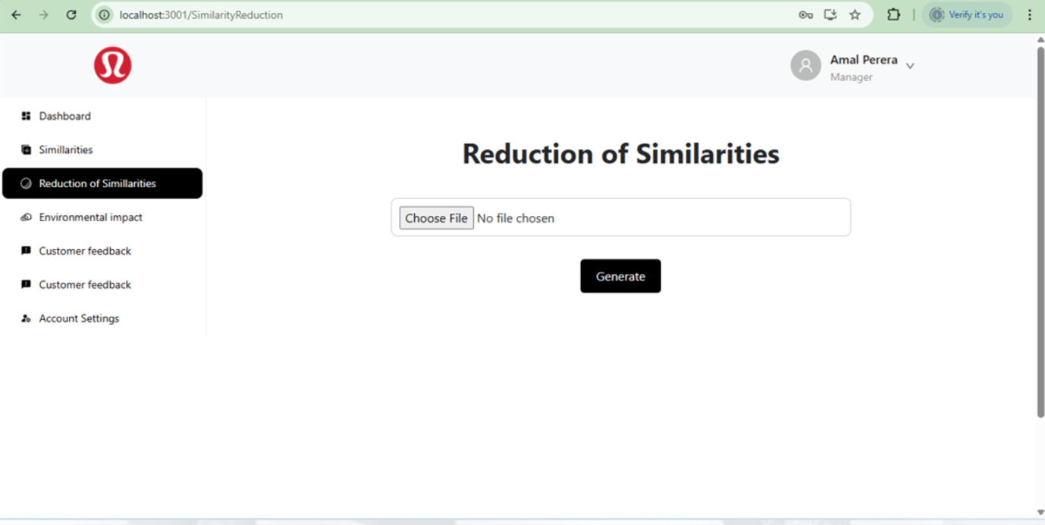

# Conclusion

In order to make it easier to analyze how designs evolve, the project intends to create a reliable model that can precisely measure and categories the similarities between historical and modern fashion designs. Additionally, it will develop a useful recommendation system that offers concrete recommendations for altering designs, enabling fashion designers to produce original looks while taking upcoming trends into account. Through the use of trend forecasting algorithms, the initiative will help designers remain ahead of consumer needs. All of these tools will be integrated into a user-friendly online interface so that designers may readily access them inside their workflow. This project's practical applications include giving fashion designers new tools to set themselves apart from the competition and follow emerging trends, giving the fashion industry a state-of-the-art tool to boost creativity and streamline the design process, and advancing academic research by examining the nexus between machine learning, data analytics, and fashion design.

# References

1. A. Krizhevsky, I. Sutskever, and G. E. Hinton, "ImageNet classification with deep convolutional neural networks," ***Communications of the ACM***, vol. 60, no. 6, pp. 84-90, 2017.

2. A. Liu, Y. Hu, and B. Jiang, "Fashion analytics: A novel image-based fashion trend forecasting system," ***IEEE Transactions on Multimedia***, vol. 20, no. 2, pp. 488-500, Feb. 2018.

3. K. Y. Wong and K. P. Chan, "Design assistance for fashion designers based on evolutionary computation,"***IEEE Transactions on Systems, Man, and Cybernetics: Systems***, vol. 49, no. 5, pp. 958-969, May 2019.

4. R. J. Hyndman and G. Athanasopoulos, ***Forecasting: Principles and Practice***, 2nd ed., OTexts, 2018.

5. J. Nielsen, ***Usability Engineering***, Morgan Kaufmann, 1994.

6. M. Armbrust *et al.*, "A view of cloud computing," ***Communications of the ACM***, vol. 53, no. 4, pp. 50-58, Apr. 2010.

7. L. Bass, P. Clements, and R. Kazman, ***Software Architecture in Practice***, 3rd ed., Addison-Wesley, 2012.

8. I. Jacobson, G. Booch, and J. Rumbaugh, ***The Unified Software Development Process****,* Addison-Wesley, 1999.

9. C. Kaner, J. Falk, and H. Q. Nguyen, ***Testing Computer Software****,* 2nd ed., John Wiley & Sons, 1999.

10. B. Garret, **T*he Elements of User Experience: User-Centered Design for the Web and Beyond,*** New Riders, 2010**.**

# Appendix

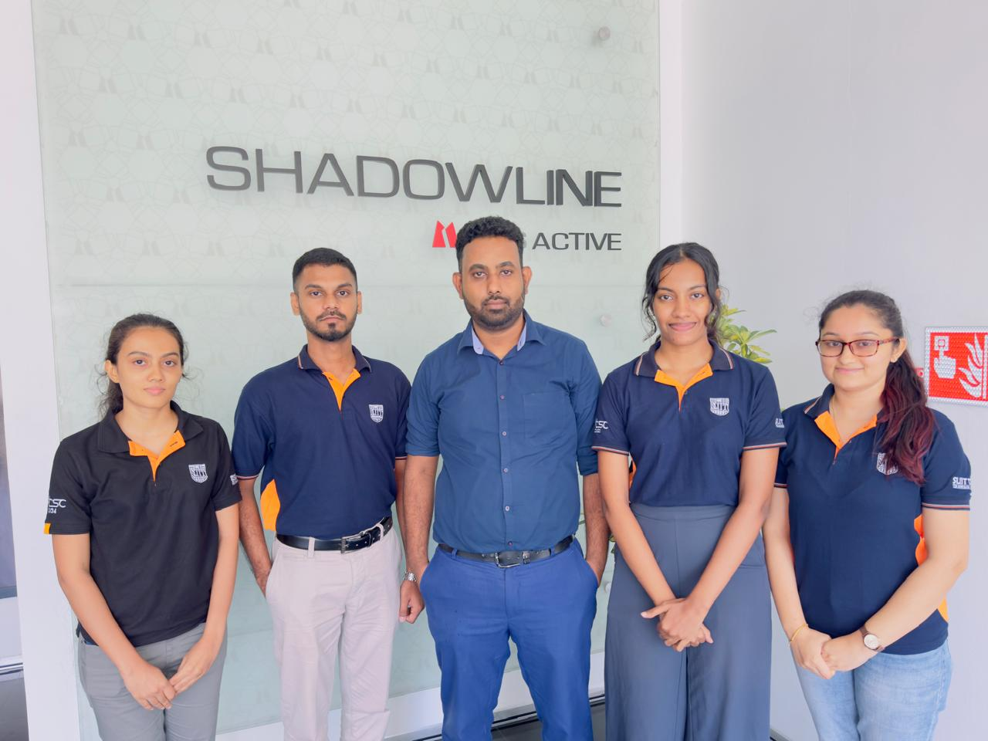

Figure 4-Group photo at a site visit